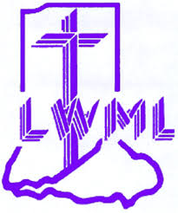
LWML Indiana District Scholarship

Did you know that the LMWL Indiana District gives $500 scholarships to help with tuition to upcoming pastors and professional church workers?
The Indiana District LWML recognizes the need to actively inspire more young people to pursue church related professions and also the need to make monies available in all phases of the Lord’s work in the Lutheran Church Missouri Synod.

You can help in this endeavor by donating money for scholarships for those young people who are pursuing these professions.
You can contribute any amount, anytime to the scholarship fund. A suggestion would be to donate as a gift instead of a buying a present. The committee has JOY and MEMORIAL cards available to do this.
JOY cards are used to commemorate someone's birthday, anniversary, graduations, weddings, MEMORIAL cards are used to honor deceased loved ones.

Share this email with your congregation members
(Instructions, JOY, MEMORIAL cards are on the next page)

1. Print the Instructions, fill out and send to the Financial Secretary with your donation.
2023-25 Financial Secretary:
Rachel Huebschman
241 E. Robert E Lee Day Rd.
Santa Claus, IN 47579
Be sure to include your check. The Financial Secretary will forward this information to the
Scholarship chairperson (or go to lwmlindiana.org, resources, church worker scholarship)

If you have questions, contact Renee South, the Scholarship Chair.
2023-25
Renee South
south87@sbcglobal.net

2. Fill out the JOY or MEMORIAL card and send in a separate envelope to the appropriate honoree or bereaved.
(Donations can be given without a JOY or MEMORIAL card.)
Instructions
For donating to the Indiana District LWML Scholarship Fund

1. Fill out the following and mail with your contribution to the Indiana District LWML Financial Secretary.
2. Mail or give the JOY or MEMORIAL card to the Honoree or the Bereaved

We enclose $___________, given to the Indiana District Lutheran Women’s Missionary League Scholarship Fund.

______ IN JOYFUL RECOGNITION OF _______________________________________________

______ IN MEMORY OF __________________________________________________________

Given by
NAME ________________________________________________________________________

ADDRESS ______________________________________________________________________

CITY _______________________________ STATE_______________ ZIP ___________________

IF you wish an acknowledgement sent, please supply the following information

NAME ________________________________________________________________________

ADDRESS ______________________________________________________________________

CITY _______________________________ STATE_______________ ZIP ___________________

The Indiana District LWML recognizes the need to actively inspire more people to pursue church related professions and and also the need to make monies available within our District for the education and training in all phases of the Lord’s work in the Lutheran Church, Missouri Synod.

“I THANK GOD EVERY TIME I REMEMBER YOU.”
Phillippians 1:3

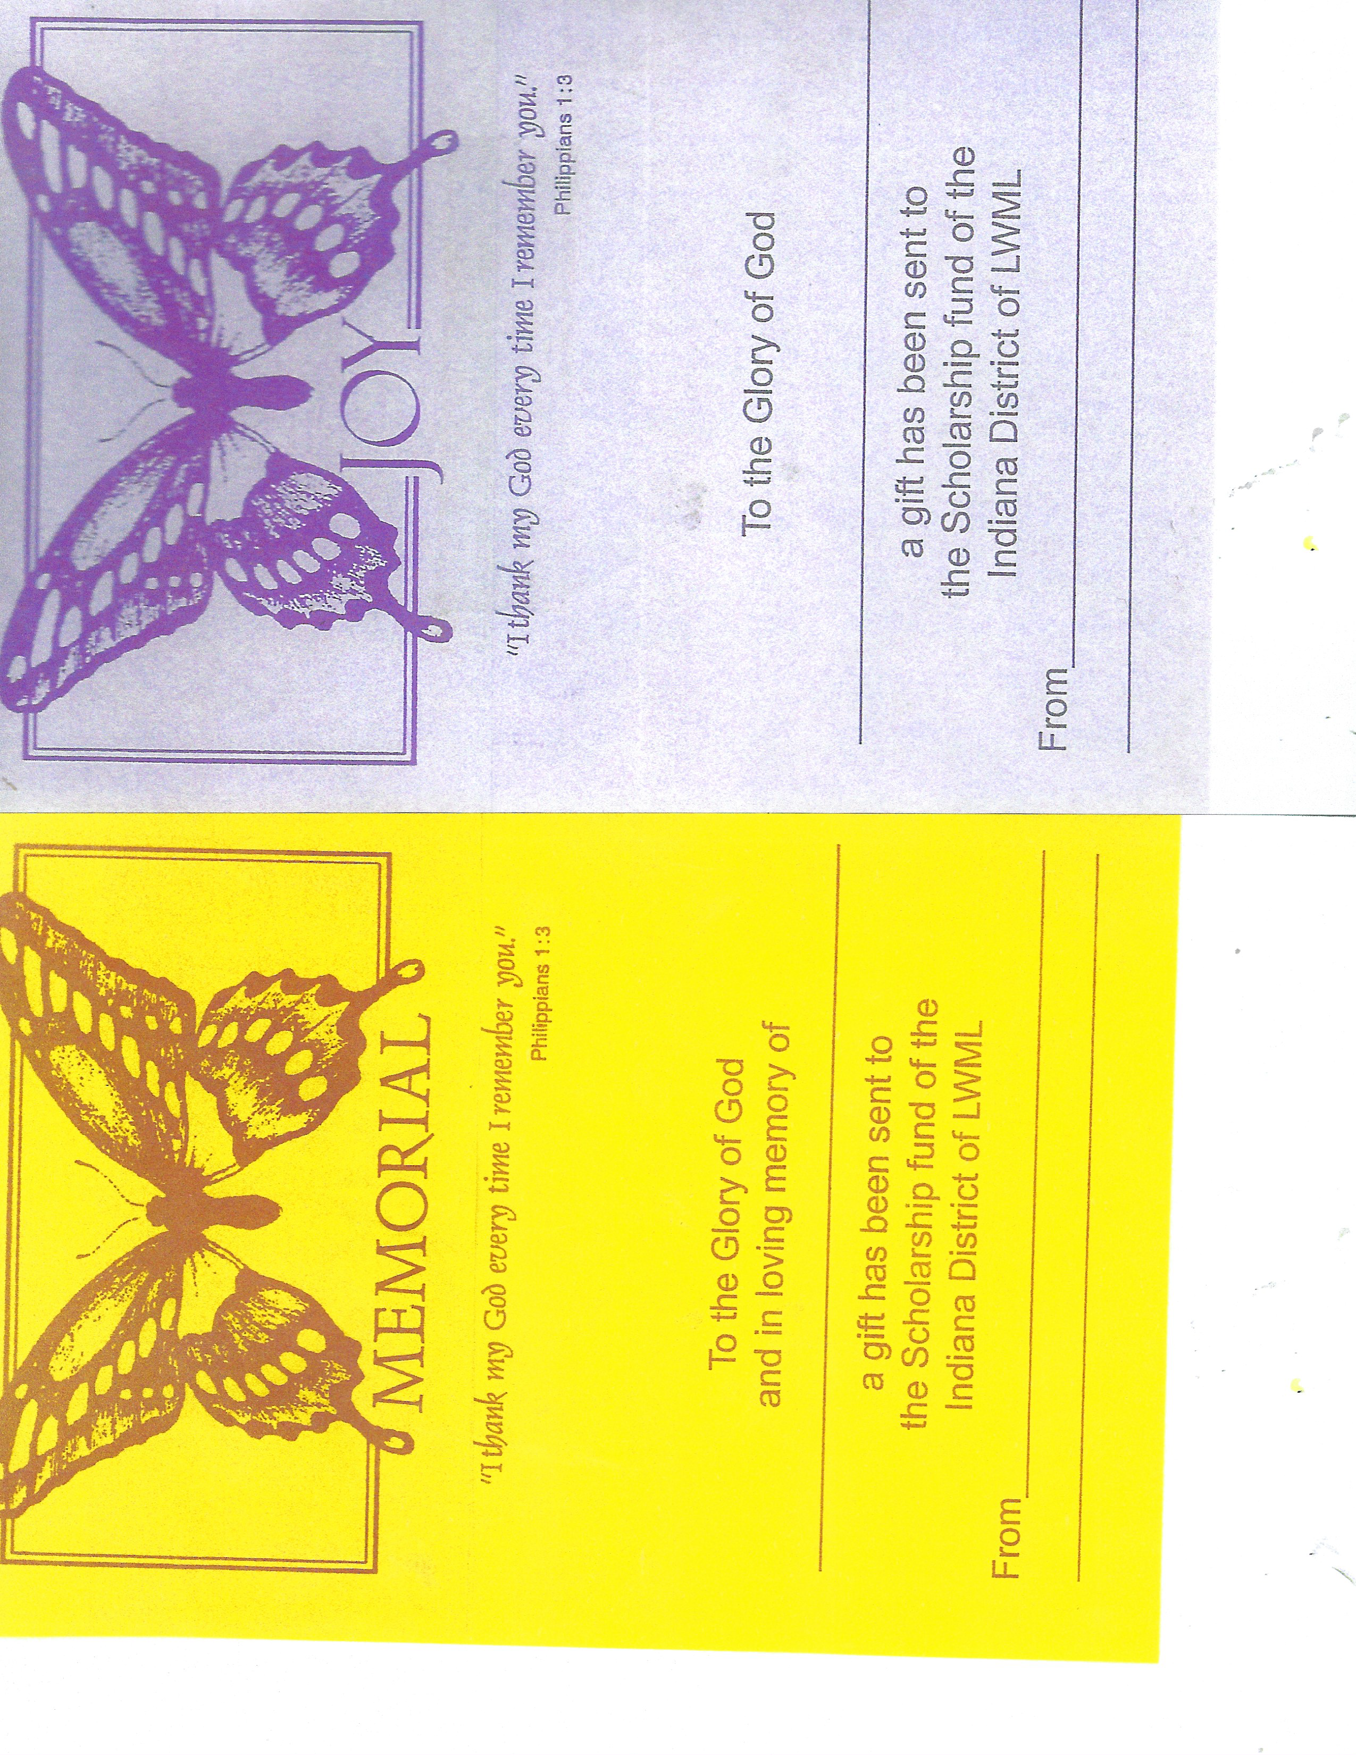

Who is eligible for these scholarships?
Applicant must be a communicant member of a congregation of the LCMS in the Indiana District for at least 18 months prior to filing of application and is preparing to be a servant of the church, on a fulltime basis. (Ministry, teaching, Parish worker, DCE, Deaconess, etc). They must attend an LCMS synodical school, present a demonstrable need for such aid, and show a good scholastic aptitude in previous schooling.

Each student desiring a scholarship must make an annual application, which is issued for a period of one year only. Applications are available on lwmlindiana.org under resources, church worker scholarships and can be mailed by March 10 of each year or emailed to the scholarship chair by March 15 of each year. Her name can be found at lwmlindiana.org, resources, church workers scholarship or on the last page of the Indiana LWML Good News.

Regulations regarding scholarships

1. By Indiana District LWML Resolution, each scholarship to be allotted shall be in the amount of $500.
2. Monies shall be made payable to the school according to the number of terms per traditional school year.
3. The Indiana District Scholarship Committee is responsible for screening all applications and designating the recipient(s) of a scholarship.
4. Students who discontinue their studies are expected to inform the committee of their action as early as possible.
5. Monies for support shall not be sent to the student, but directly to the appropriate administrative person in charge of funds.
6. No application shall be considered unless the school of the prospective student shall have first approved of the enrollment.

